Ideation Phase
Brainstorm & Idea Prioritization Template

Date | 31 January 2026
Team ID | LTVIP2026TMIDS87294
Project Name | ResolveNow: Your platform for online complaints
Maximum Marks | 4 Marks

Step-1: Team Gathering, Collaboration and Problem Statement Selection

Team Discussion
Our team conducted a collaborative discussion session to analyze common issues faced by organizations in complaint management systems. We identified the following recurring challenges:
- Manual handling of complaints through emails or paper records
- Lack of centralized complaint tracking
- Delays in complaint resolution
- Poor communication between customers and support teams
- Limited transparency in complaint status
- Risk of data loss and security concerns
After evaluating these issues, we selected the following problem statement.

Selected Problem Statement
Organizations lack a centralized, secure, and intelligent platform to efficiently register, track, assign, and resolve customer complaints while maintaining transparency and compliance with regulations.

Step-2: Brainstorming, Idea Listing and Grouping

Raw Brainstorm Ideas
During the brainstorming session, the team generated the following ideas without filtering:
- Online complaint submission form
- Complaint tracking dashboard
- Role-based access system
- Real-time chat between user and agent
- AI-based complaint categorization
- Intelligent complaint routing
- SMS and email notifications
- File and image upload support
- Admin analytics dashboard
- Complaint priority ranking
- Feedback and rating system
- Secure encrypted database
- Report generation feature
- Complaint severity scoring
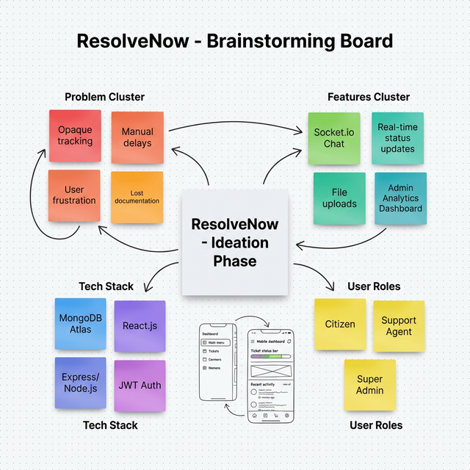

Idea Grouping
After listing ideas, we grouped them into logical categories:

Core Functional Features
- Complaint submission system
- Complaint tracking
- Status updates
- File attachments
- Notifications

Smart & Advanced Features
- AI-based categorization
- Intelligent routing
- Priority ranking system
- Data analytics dashboard

Communication Features
- Real-time chat
- Email notifications
- SMS alerts
- Feedback collection

Security & Compliance Features
- User authentication
- Role-based authorization
- Data encryption
- Secure database storage

Step-3: Idea Prioritization
To prioritize ideas, we evaluated them based on:
- Impact on users
- Technical feasibility
- Innovation level
- Development time

Priority Table
Feature | Impact | Feasibility | Priority Level
Complaint Submission | High | High | Very High
Tracking Dashboard | High | High | Very High
Role-Based Access | High | High | Very High
Real-Time Chat | High | Medium | High
AI Categorization | Medium | Medium | Medium
SMS Integration | Medium | Low | Low

Final Selected Features
Based on prioritization, the team finalized the following features for implementation in the ResolveNow system:
- User Registration and Login
- Complaint Submission and Tracking
- Role-Based Dashboards (User, Agent, Admin)
- Complaint Assignment and Routing
- Real-Time Chat Functionality
- Email Notifications
- Secure Data Storage using MongoDB
- Admin Analytics Dashboard

